NAT (Dynamic) Configuration

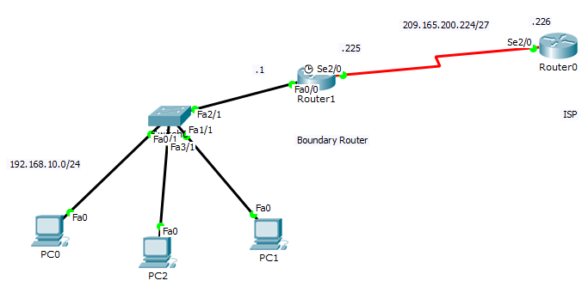
To configure the DHCP the following commands can be executed:

/*Configure the Router R1 (Boundary router) for Fast-Ethernet interface (Fa0/0) and Serial Interface (Ser2/0)*/
Router 1 (Configuration)# interface FastEthernet0/0
Router 1 (Configuration-if)# ip address 192.168.10.1 255.255.255.0
Router 1 (Configuration-if)# no shutdown

Router 1 (Configuration)# interface Serial2/0
Router 1 (Configuration-if)# ip address 209.165.200.225 255.255.255.224

/* Configure the Router R0 (ISP) for Serial Interface (Ser2/0) */
Router 0 (Configuration)# interface Serial3/0
Router 0 (Configuration-if)# ip address 209.165.200.226 255.255.255.224

/* Define static root on ISP router */
! For accessing the network 192.168.10.0/24
Router 0 (Configuration)# ip route 192.168.10.0 255.255.255.0 Serial2/0

/* Define default root on Router R1 (Boundary router) */
! For accessing the internet from network 192.168.10.0/24
Router 1 (Configuration)# ip route 0.0.0.0 0.0.0.0 Serial2/0

/* Configure NAT configuration on Router R1 (Boundary Router) */
! Define address range for the NAT pool
Router 1 (Configuration)# ip nat pool NAT_POOL1 209.165.200.226 209.165.200.240 netmask 255.255.255.224
! Define ACL to permit the hosts; 0.0.0.255 is the super netting of mask
Router 1 (Configuration)# ip access-list standard ACL1
Router 1 (Configuration)# Permit 192.168.10.0 0.0.0.255
! Bound the ACL to the NAT pool
Router 1 (Configuration)# ip nat inside source list ACL1 pool NAT_POOL1 overload
! Define the inside interface of the router for the NAT
Router 1 (Configuration)# interface fa0/0
Router 1 (Interface)# ip nat inside
Router 1 (Interface)# no shutdown
Router 1 (Interface)# exit
! Define the outside interface of the router for the NAT
Router 1 (Configuration)# interface ser2/0
Router 1 (Interface)# ip nat outside
Router 1 (Interface)# no shutdown

